
LKSN 2024

TEKNOLOGI
DESAIN GRAFIS

Module 4 (EN)
Editorial Design and Digital Publishing

LKS Nasional
AGUSTUS 2024

INSTRUCTIONS FOR COMPETITOR

- Create a folder named Competitor Number_Your Name
  - The folder must contain all final files in the format specified in the technical specification.
- You must use all the text provided in the appendix for each tasks as specified, adding or subtracting text from the appendix is ​​not allowed.
- You may use the image/photo assets that have been provided.
- You may use create raster element or additional vector provided.
- You are not permitted to use images/photos from internet or from sources other than provided.

Example of arranging folders on a Competitor’s computer:
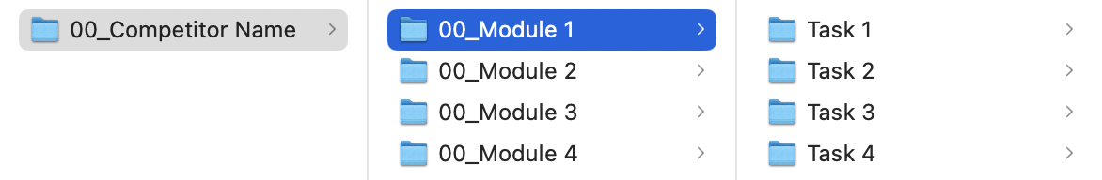

MODULE FOLDER
Modul 4

PROJECT DESCRIPTION AND TASKS
This module consists of 2 (Two) tasks that you have to do, you are not allowed to do outside the time limit that has been given.

TASK 1: LOGO IMPLEMENTATION

OBJECTIVE
Apply the logo and visual identity to the certain media using the key visual that explained in the Module Y:
- 1 x Keychain
- 1 x Totebag

REQUIREMENT
You must include:
- Logo Studio on Fire
- QR Code

TECHNICAL SPECIFICATION
Dimension : 1920 x 1080 px (Landscape)
Image Resolution : 72 ppi
Color Mode : RGB
Design Element : 1 x Logo, Kode QR
Text : Module 4 Appendix 1.pdf

Working File Format : PSD
Final File Format : JPG
Image Format : PNG, JPG, PSD, AI, EPS, SVG

Folder Name : Competitor Number_Module 4
Sub Folder Name : Task 1
File Name : Competitor Number_Module 4_Keychain
Competitor Number_Module 4_Totebag

YOU MUST DELIVER
Folder & file names as specified in "INSTRUCTIONS FOR COMPETITOR".
Only links & files from this folder will be marked.

2x PSD (Working File) - with maximum file size 30 MB per PSD
2x JPG (Final File)

TASK 2: BRAND GUIDELINE

OBJECTIVE
Create a rules for a logo includes rules for color, typography, graphic elements & image style, and logo implementation into a Brand Guideline system design.

REQUIREMENT
You must include:
- Apply text provided in appendix
- Logo Studio on Fire

12 PAGES CONTAIN
- Front Cover
- Background
- Logo
- Prohibitions in Logo Usage
- Colour
- Typography
- Supergraphic and Photography
- Printed Media Implementation
- Digital Media Implementation
- Merchandise Design
- Credit
- Back Cover

TECHNICAL SPECIFICATION
Dimension : A4 - 297 x 210 mm (Landscape)
Image Resolution : 150 ppi
Color Mode : CMYK
Text : Module 4 Appendix 1.pdf

Working File Format : INDD
Final File Format : PDF
Image Format : PNG, JPG, PSD, AI, EPS, SVG

Folder Name : Competitor Number_Module 4
Sub Folder Name : Task 2
File Name : Competitor Number_Module 4_Guideline

YOU MUST DELIVER
Folder & file names as specified in "INSTRUCTIONS FOR COMPETITOR".
Only links & files from this folder will be marked.

1 x PDF-X4:2008 (Final File)
1 x INDD - Packaged (Working File)

